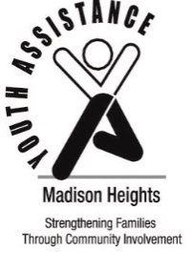
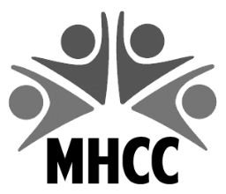
Madison Heights Community Coalition
300 West 13 Mile Road
Madison Heights, MI 48071
248.837.2665
mhcfc@madison-heights.org

Madison Heights
Youth Assistance
31201 Dorchester Avenue
Madison Heights, MI 48071
248.589.6860

YOUTH RECOGNITION AWARD
STUDENT RECOGNITION FORM – 2020

Please fill in ALL shaded areas.
STUDENT’S NAME | Enter first and last name. |  |  | GENDER |  | MALE |  | ☐ | FEMALE | ☐
IF NAME IS DIFFICULT TO PRONOUNCE, HOW IS THE NAME PRONOUNCED? |  |  |  | Enter pronunciation.
ADDRESS | Enter address. | CITY | Enter city. |  |  |  |  | ZIP | Enter zip.
SCHOOL | Enter school. | GRADE |  | Select grade. | PHONE |  | Enter phone number.
PARENT/GUARDIAN NAMES | Enter first and last names.
EMAIL ADDRESS | Enter email address of parent/guardian.

DESCRIPTION OF NOMINEE’S ACCOMPLISHMENTS AND/OR SPECIAL ACHIEVEMENTS

Please limit description to 55 words or less. Any description more than 55 words will be eliminated from the program. Please note, the following information will be printed in the 2020 Youth Recognition Program AS WRITTEN BELOW.

Enter volunteer service.

NOMINATOR’S INFORMATION
NOMINATOR’S NAME |  | Enter name. |  | TITLE |  | Enter title.
NOMINATOR’S ORGANIZATION/SCHOOL |  | Enter organization/school.
NOMINATOR’S ADDRESS |  | Enter address. |  | CITY | Enter city. |  | ZIP | Enter zip.
NOMINATOR’S PHONE # |  |  | NOMINATOR’S EMAIL ADDRESS

*****NOMINATIONS MUST BE RECEIVED BY MARCH 31, 2020*****

Send nominations to: Madison Heights Community Coalition
300 West Thirteen Mile Road
Madison Heights, MI 48071

Or email to: mhcc@madison-heights.org

Questions: Kimberly Heisler, 248-837-2665
Deb Lindsey, 248-589-6860

