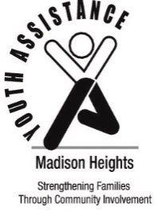
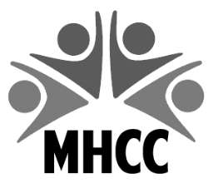
Madison Heights Community Coalition
300 West 13 Mile Road
Madison Heights, MI 48071
248.837.2665
mhcfc@madison-heights.org

Madison Heights
Youth Assistance
31201 Dorchester Avenue
Madison Heights, MI 48071
248.589.6860

2023 YOUTH RECOGNITION PROGRAM
STUDENT NOMINATION FORM
Please fill in ALL shaded areas.
STUDENT’S LEGAL NAME |  | GENDER MALE FEMALE
IF NAME IS DIFFICULT TO PRONOUNCE, HOW IS THE NAME PRONOUNCED?
ADDRESS | CITY |  |  | ZIP
SCHOOL | GRADE |  | PHONE
PARENT/GUARDIAN NAME
EMAIL ADDRESS (Preferred for advance notice of invitation.)

DESCRIPTION OF STUDENT’S ACCOMPLISHMENTS AND/OR SPECIAL ACHIEVEMENTS
Nominators: Please limit description to 55 words or less. Any description more than 55 words will be eliminated from the program. Please note, the following information will be shared and printed in the 2023 Youth Recognition Program AS WRITTEN below.

_______________________________________________________________________________________________________________________________________________________________________________
____________________________________________________________________________________________________________________________________________________________________________________________________________________________________________________________
____________________________________________________________________________________

____________________________________________________________________________________________________________________________________________________________________________________________________________________________________________________________
____________________________________________________________________________________________________________________________________________________________________________________________________________________________________________________________________________________________________________________________________________________________________________________________________________________________________
NOMINATOR’S INFORMATION
NOMINATOR’S NAME |  | TITLE
NOMINATOR’S ORGANIZATION/SCHOOL
NOMINATOR’S ADDRESS |  | CITY | ZIP
NOMINATOR’S PHONE # | NOMINATOR’S EMAIL ADDRESS

****FORMS MUST BE RECEIVED BY MARCH 24, 2023****

Send recognition forms to: Madison Heights Community Coalition
300 West Thirteen Mile Road
Madison Heights, MI 48071

Or email to: mhcc@madison-heights.org

Questions: Kimberly Heisler, 248-837-2665
Deb Lindsey, 248-589-6860

