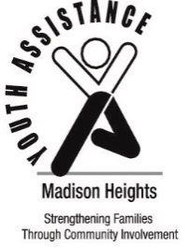
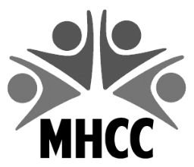
Madison Heights Community Coalition
300 West 13 Mile Road
Madison Heights, MI 48071
248.837.2665
mhcfc@madison-heights.org

Madison Heights
Youth Assistance
31201 Dorchester Avenue
Madison Heights, MI 48071
248.589.6860

2023 YOUTH RECOGNITION PROGRAM
RECOGNITION CRITERIA

- Honoree Criteria:
    - A student must either reside in Madison Heights, or attend school in Madison Heights.
    - Any student in 1st through 12th grade.
    - Students should be considered for showing EXCEPTIONAL SERVICE TO OTHERS i.e. displays incredible initiative and extreme concern for others. Commitment and individual initiative are qualities considered.
    - Students should also be considered if they are OVERCOMING PERSONAL CHALLENGES and have made achievements in personal growth, social development, attitudes and behaviors.
        - Making positive changes and progress is evident
        - Overcoming significant personal hardships, obstacles or circumstances
    - Paid services, required community service, activities for school credit, class assignments, scouts, sports, National Honor Society, church or the courts are NOT eligible.
- High school seniors may be eligible for continuing education scholarships.
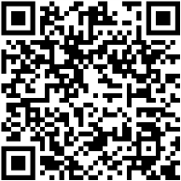
- Nominators may be any adult (immediate relatives are excluded) or organization.
- Nominations should be submitted using the 2023 Youth Recognition Nomination form.
    - Electronic forms are available on MHCC’s website, www.MadisonHeightsCC.com .
- Illegible or incomplete forms will not be considered.
- Each school will have up to five students recognized.
- Due to the fact that this is an individual award, group selections are ineligible. However, selections for an individual who stands out in his/her group are welcome.
If you need additional information, please do not hesitate to call Deb at the MHYA office, 248.589.6860 or Kimberly at the MHCC office, 248.837.2665.
Recognition forms MUST BE RECEIVED BY MARCH 20, 2023
Send recognition forms to: Madison Heights Community Coalition
300 West Thirteen Mile Road
Madison Heights, MI 48071

Or email to: MHCC@madison-heights.org

